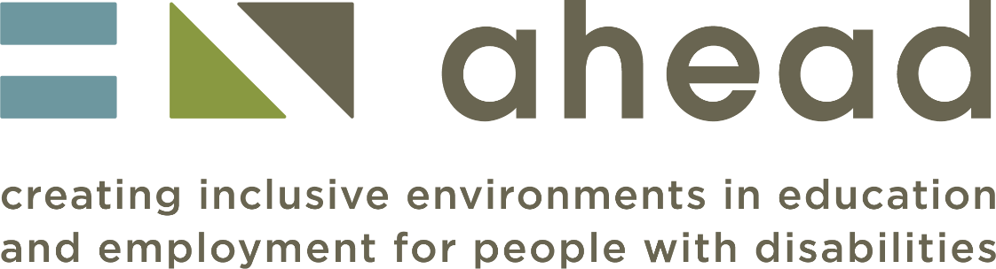

AHEAD Accessibility Statement for ARK Courses
November 2023

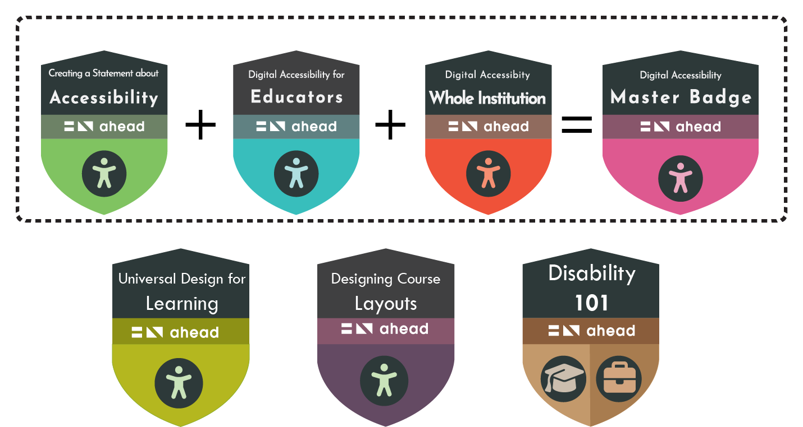

Contents
Introduction 4
Context 5
About ARK 5
Why Improve Digital Accessibility – Legal and Reputational View 5
Encouraging Staff to Take the Courses Directly with AHEAD 6
Embedding ARK Courses in Institutional CPD Systems 7
Accessing the Course Files 8
SCORM Files 8
Articulate Rise Files 8
Word Versions of Course Content 8
Course Accessibility Statements and Templates 8
Using the Other Resources in Your Institution 8
Terms of Use of Ark Resources 8
What should work for all users (and how it helps) 10
Visual Appearance 10
Colours: 10
Magnification: 10
Navigation 10
Module level: 10
Page level: 10
Hyperlinks: 11
Skip links: 11
Landmarks 11
Media 11
Keyboard accessibility 11
Text-to-speech compatibility 11
Known Issues 12
Moodle course image 12
Visual Appearance 12
Colours: 12
Videos 12
Interactive graphics 12
Multichoice quizzes 12
Preparation of this statement 13
Feedback and contact information 13
Version History 13

Introduction

This is the accessibility Statement for AHEAD online accessibility short courses. It applies to the following courses:

- Digital Accessibility - A Whole Institutional Approach,
- Digital Accessibility for Educators,
- Developing an Accessibility Statement,
- Designing Course Layouts for Learner Success,
- Universal Design for Learning - Getting started,
- Disability 101: Awareness, Inclusion, and Equity.

This content has been developed to be as accessible as possible within the constraints of the tools available. Being accessible gives more options for more users and allows you to personalise your view of the content and to explore it on a range of platforms from mobile phones to laptops, tablets, or screen readers.

The courses have been created on Articulate Rise and are delivered via the AHEAD Moodle platform. There is a downloadable Word version available for each course too. This has the same content (but obviously not the interactivities).

If it is helpful to you, we provide links below to more information on the accessibility of Articulate Rise and the Accessibility of Moodle.

Articulate Rise voluntary product accessibility template (VPAT)

RISE progress on accessibility to date

Moodle platform accessibility guidance

Context

This ARK Digital Accessibility Awareness and Compliance Pack supports senior managers and other professionals involved in raising institutional accessibility standards and compliance in Irish further and higher education centres/institutions, to effectively use the short courses and resources in ARK to support their work. If part of your role involves supporting your centre/institution to comply with laws concerning digital accessibility and equality, and/or to ensure that all staff have the knowledge and skills to support compliance and improve the learner experience, then this pack is for you.
The core funding received by AHEAD for its further education activities on fostering inclusion is provided by SOLAS, and this grant has supported the development of this work.

About ARK

ARK is AHEAD's home for digital accessibility resources and know-how in tertiary education. Digital accessibility is key to inclusion, as it provides more equal access for students and staff to engage with institutions, their services, and related educational materials in multiple ways.
ARK provides practical resources and know-how to support a range of institutional staff to be more accessible in their roles and supports colleges and centres to consider a whole institution approach to digital accessibility, meet their legal obligations, boost accessibility compliance, and provide a better digital experience for all.

Built into ark is:
- A range of free role-based 2 hr short courses for educators, administrative, senior and technical staff, which can be taken directly with AHEAD, or used in internal CPD systems under a creative commons license – most of the information in this pack is aimed at supporting institutions to use these courses to raise digital accessibility awareness and compliance.
- An introduction to key web accessibility legislation for further and higher education institutions and a legal FAQ on what the web accessibility directive means in practice.
- Links to lots of other valuable AHEAD and external resources to continue your accessibility journey that you can find below.
Within this pack, we will refer to individuals like you who are using these resources to improve accessibility within your institution or department as ARK Facilitators.

Why Improve Digital Accessibility – Legal and Reputational View
The EU Web Accessibility Directive (Directive (EU) 2016/2102) has been signed into Irish Law. The directive affords people with disabilities with improved access to websites and mobiles apps of public services, and most further and higher education centres/institutions fall under its remit. Yet, in the first round of accessibility monitoring conducted by the assigned monitoring body under this law, the Education and Training Boards and higher institutions randomly selected for monitoring showed low levels of compliance with legal accessibility standards. The institutions selected received accessibility scores of between just 22% and 36%, with each institution reported to have hundreds of critical accessibility issues identified during the monitoring process.
Not addressing digital accessibility at an institutional level now represents a clear legal and reputational risk. You can find out more by undertaking the free short courses within ARK.
Why Improve Digital Accessibility – Learner Access and Usability
But, in all the focus on compliance and meeting legal responsibilities, we shouldn’t forget the huge benefits to both institutions and learners of raising digital accessibility standards. Providing digital environments and materials which have strong levels of accessibility built in can:
- Make your systems and materials easier to use and navigate for all students and staff, but especially those with disabilities, ensuring greater equity of access.
- Reduce the need for add-on supports and reasonable accommodations for students and staff with disabilities, providing them with greater agency and independence in how they work and learn.
- Support greater return on investment in accessibility/productivity features built into tools you have already procured, by ensuring platforms and tools are optimised for use by students and staff.

This pack and the courses and resources built into ARK can support you as an ARK Facilitator to work towards an institutional approach to digital accessibility that results in a better digital experience for all. If you are working towards this goal, we suggest taking the free ARK short courses as a starting point, and then considering how best to use the ARK resources within your institution.

ARK Facilitators can encourage staff to take the courses directly with AHEAD, or to use the course files provided in this pack to upload the courses to their own learning management systems, and track completion themselves. Because these courses have been made available by AHEAD under a CC BY-NC-SA creative commons license (see more in Terms of Use Section), institutions can if they wish adapt or modify the courses to make certain parts more relevant for their institution, for example by including information about localised accessibility features/tools.

So, for ARK Facilitators, the first key decision to make is to decide which approach to take. Each one has pros and cons explored below.

Encouraging Staff to Take the Courses Directly with AHEAD

How: Simply adapt the Email template in Appendix 1 and send it to relevant staff, notifying them of which courses they should take, highlighting that they should complete the courses by X date return the evidence of the digital badge issued to them. Once you have communicated this to staff, all you must do is keep a record on who has completed the badges and send reminders to those who have not done so. Any completions on the AHEAD platform will automatically be issued with a Digital Badge through Open Badge Factory.

Pros of this Approach: minimal administration, setup etc, and getting quick results and a reasonable level of oversight.

Cons of this Approach: less systematic approach to professional development around accessibility, less sustainable (reliance on AHEAD).

Most Useful For: ARK Facilitators seeking quick results at the centre or departmental level.

Embedding ARK Courses in Institutional CPD Systems

ARK Facilitators considering this approach should explore recruiting internal support from a professional within your centre/institution familiar with setting up courses on your learning management system (LMS – e.g., Moodle, Canvas etc.). Please note that if using this method, no AHEAD digital badge will be issued, but institutions may if they wish award their own internal digital badges for completion.

To support ARK Facilitators to have options in how to use ARK courses within their institution’s LMS, AHEAD have included multiple file types within this pack.
- If institutions wish to use the courses as they are without adaptation, AHEAD have provided these completed course files as SCORM files. SCORM is an international standard file type which is supported by most learning management systems, and when the courses are uploaded, they will look identical to the visually appealing layouts used on the AHEAD platform. This method requires no additional software and no editing of files, just some setup within the LMS itself.
- If institutions wish to adapt the content of format of the courses, there are two options available:
  - Adapting content using Articulate Rise: ARK Facilitators can ask to have a copy of the course authoring files shared with them in Articulate Rise which was used to develop the courses by making a request to aheadcourses@ahead.ie. To facilitate this, the institution must have access to an Articulate 360/Rise subscription, and the ARK Facilitator must provide the email address linked to the subscription in the email request to AHEAD. Once AHEAD have shared the courses, a copy of them will appear in the Rise account given, and ARK Facilitators can the edit the content as desired and output them as a finished SCORM file, before uploading them as a course to the LMS.
  - Using Word Files to Create Course in a Native Format: For those who wish to edit the content but do not have access to Rise, or who wish to using a different authoring tool favoured by their institution (for example H5P or Moodle Book), they can recreate the courses in whatever format they wish, copying from the Word versions provided and recreating the learning interactions as described in the Word docs. Links to all captioned video content hosted in YouTube are included in the word files.

How: Engage with an eLearning professional in your institution to support you to make the right choice on which option to take, and what if any adaptations should be made to the content. Once you have made the adaptations and have the final course files, set each up as a course within the LMS. Be sure to set completion settings so you can track completion within the course, and ideally, set up an internal digital badge or cert to be issued to staff who complete each course. You can use the template course level accessibility statement provided in this pack if you wish to provide an accessibility statement for these courses (recommended).

Pros of this Approach: more systematic approach, with greater control and sustainability for institutions. Ability to embed in existing CPD systems and processes e.g., induction.

Cons of this Approach: much more effort, coordination and oversight required, requires support from staff with knowledge of eLearning systems/LMS/course authoring tools, updates developed in-house.

Most Useful For: ARK Facilitators seeking to build sustainable approaches to accessibility CPD, and whom have access to institutional resources to support course implementation.

Accessing the Course Files

Read the sections above and then decide which files you require for your approach:

SCORM Files
SCORM File: An Introduction to Digital Accessibility for Educators,
SCORM File: Digital Accessibility - A Whole Institution Approach,
SCORM File: Developing a Web Accessibility Statement,
SCORM File: Universal Design for Learning: Getting Started,
SCORM File: Designing Course Layouts for Learner Success,
SCORM File: Disability 101: Awareness, Inclusion, and Equity.

Articulate Rise Files
ARK Facilitators can ask to have a copy of the course authoring files shared with them in Articulate Rise which was used to develop the courses by making a request to aheadcourses@ahead.ie. To facilitate this, the institution must have access to an Articulate 360/Rise subscription and the ARK Facilitator must provide the email address linked to the subscription in the email request to AHEAD. Once AHEAD have shared the courses, a copy of them will appear in the Rise account given, and ARK Facilitators can the edit the content as desired.

Word Versions of Course Content
You can download the Word Versions of each of the eLearning modules from the Google Drive folder.
- Word Version: Universal Design for Learning: Getting Started,
- Word Version: Designing Course Layouts for Learner Success,
- Word Version: Digital Accessibility for Educators,
- Word Version: Creating an Accessibility Statement,
- Word Version: A Whole Institution Approach,
- Word Version: Disability 101: Awareness, Inclusion, and Equity.

Course Accessibility Statement and Templates
You can download the SCORM version of this Accessibility Statement from the Google Drive folder too. Please note: this Word Document version is the most up-to-date and current version of the Statement. The SCORM file is simply an additional way to engage with the information.

SCORM version of the Accessibility Statement

Using the Other Resources in Your Institution

Remember – ARK is not all about the short courses available. There are lots of other resources within ARK which you can link to or embed on your institutions website or internal repositories so don’t forget to explore and use them in line with the Terms of Use outlined below.

Terms of Use of Ark Resources

All the AHEAD developed resources contained in ARK can be used by institutions under creative commons licenses of different kinds, unless otherwise stated, without the need to obtain specific permission from AHEAD. The categories of resources and associated licenses are as follows:
- All short courses contained within ARK can be freely used by centres/institutions under a CC BY-NC-SA creative commons license: This license allows re-users to distribute, remix, adapt, and build upon the material in any medium or format for non-commercial purposes only, and only so long as attribution is given to the creator. If you remix, adapt, or build upon the material, you must license the modified material under identical terms. This means that centres/institutions can if they wish adapt ARK courses for their local context. The ‘BY’ part of the license means that credit must be given to the creator – “This resource was developed by AHEAD and Alistair McNaught”, or if they have been modified or adapted, “This resource is adapted from work originally developed by AHEAD and Alistair McNaught and is made available under a CC BY-NC-SA creative commons license”. The ‘NC’ means that only non-commercial uses of the work are permitted i.e., that the resources cannot be used as part of the work of a commercial business enterprise or any other profit-making venture without AHEAD’s specific written permission. The ‘SA’ part of the license means that any adaptations must be shared under the same creative commons license, meaning any future work that builds on these courses is useable as a resource by the community.
- All other AHEAD-developed accessibility related resources referenced within Ark can be used by centres/institutions under a CC BY-NC-ND creative commons license. This license allows re-users to copy and distribute the material in any medium or format in unadapted form only, for non-commercial purposes only, and only so long as attribution is given to the creator. This license means it is easy to download these resources and upload them to institutional libraries or resource repositories without the need to seek permission. The ‘BY’ part of the license means that credit must be given to the creator – “This resource was developed by AHEAD.” The ‘NC’ means that only non-commercial uses of the work are permitted i.e., that the resources cannot be used as part of the work of a commercial business enterprise or any other profit-making venture without AHEAD’s specific written permission. The ‘ND’ part of the license means that no derivatives or adaptations of the work are permitted. Examples of the ARK resources that fall under this type of license are:
  - The Web Accessibility Directive: A legal viewpoint on practical ramifications for Irish further and higher education providers
  - The UDL for FET Resource Hub
  - The Ally Ship Student Union Accessibility Resources
  - AHEAD’s Digital Accessibility Webinar Series
- Resources signposted in the Useful External Resources Page within ARK are not the intellectual property of AHEAD, and any use of these resources should be checked with the developers of the resources directly.

What should work for all users (and how it helps)

Visual Appearance

Colours:

We have taken care to ensure the colour contrasts under our control meet accessibility guidelines for text and buttons.

We do not use colour alone to convey information. The only exception is a colour contrast quiz in one module where providing extra information would undermine the purpose of the quiz.

Using either browser settings or free browser plug-ins (such as HighContrast or
ScreenShader) it is possible to change the background colour/contrast.

Magnification:

The content is designed to be responsive. This means you can magnify in the browser up to 400% (using Control and +) without loss of functionality.

The default text size can be increased up to 200% without loss of functionality - the one exception we are aware of is a Flip card activity where the ﬁrst line on the card may be truncated.

Navigation

Module level:

You can navigate through the content using the side panel table of contents. This helps you quickly revisit content or skip ahead. Note that some sections require knowledge to build sequentially and so the ability to skip ahead may be deliberately restricted.

Each page has a link at the top leading back to the previous section. A Continue button at the bottom of the page takes you to the next section in the sequence; alternatively, the next section is access by a link named “Lesson X of Y: Lorem Ipsum”, where X is the number of the next lesson in the sequence, Y is the total number of lessons, and ‘Lorem Ipsum’ is the title of the next lesson.

Page level:

You can navigate through the content using the side panel table of contents. This helps you quickly revisit content or skip ahead. Note that some sections require knowledge to build sequentially and so the ability to skip ahead may be deliberately restricted.

Each page has a link at the top leading back to the previous section. A Continue button at the bottom of the page takes you to the next section in the sequence.

Hyperlinks:

Hyperlink text is unique and meaningful to aid navigation by screen reader users.

Skip links:

A Skip to Lesson link at the top of each page makes moving round the page much more effective for keyboard only users.

Landmarks

The course content is structured with ARIA landmarks so screen reader users can rapidly navigate between navigation items (Navigation menu, Course outline, Lesson content and Lesson header).

Media

Where relevant, we have used video clips to give a real-world context to the information. All videos have accurate captions and, where appropriate, visual content on the screen is described. Transcripts are also provided for each video.

The embedded video player is keyboard accessible and can be operated without a mouse.

Decorative images have been marked as such. Other images have been given an appropriate description. Please note that with some screen-reading software, Image Captions are read out before the Image Description/Alternative Text.

Keyboard accessibility

You can navigate the entire site and operate all its features using either a mouse or a keyboard. The relevant keys are the Tab key, Shift+Tab (to go back), the Spacebar, Enter key and the arrow keys.

The current keyboard focus is clearly visible as you tab around the content.

There is a skip to section link near the top of the page, so you do not need to tab through the menu each time you move to a new page.

There are no keyboard traps in the activity types we have chosen. However, for flashcard group activities, you may have to use arrow keys to go through the content, and the space or enter button to “flip” the card to see the back. There is no sound or audio to alert you that the card has flipped; you will know by whether the screen-reader says “front of card” or “back of card”. Similar controls may be needed for navigating through tab content, but again, this will depend on the keyboard set-up or screen-reader controls.

Text-to-speech compatibility

All the text-based content can be accessed via text to speech tools. This includes:
- commercial tools,
- built in browser tools (such as Read aloud in Microsoft Edge),
- free text-to-speech plug-ins such as Selection Reader or Read aloud.

Known Issues

Moodle course image

It is not possible to add an alt tag to the image tile representing the course on Moodle. This is in the Moodle development pipeline.

Visual Appearance

Colours:
There are parts of the Articulate Rise interface where contrasts fail guidelines – while we cannot change these as they are part of the system, we have enabled Articulate Rise’s “accessible contrast” option where it was available. We have also used Bold font to ensure that links meet colour contrast guides.

The Knowledge Check colour contrast ﬂip card activity in M3 relies on visual estimation of contrast so will not be meaningful for some visually impaired users.

The default line height cannot be adjusted using plugins such as Line Height Adjuster.

Videos

There is a small issue for screen reader users. Although the embedded videos are keyboard accessible, the Play button does not announce to a screen reader that it has become a Pause button once the content starts playing. To pause the video, listen for the Play button again!

Interactive graphics

Interactive graphics have been created to be accessible but the accessible name for each clickable hotspot is "marker" which is not intuitive. We have not found a way to change this. This activity type is used very sparingly, and there is an alternative text version of the content below this, where we have needed.

Multichoice quizzes

Some screen readers (JAWS and Windows Narrator) read the question then announce the unchecked radio button then read the question again. This was not an issue with NVDA. We have not been able to modify the code to change this behaviour.

It is useful for screen reader users to know that for quiz questions, you must click (or activate) the “Submit” button once you have selected your answer for each question, then click (or activate) the “Next” button after going through the feedback to move to the next question.

Preparation of this statement

This statement was prepared in February 2022, updated in December 2022, June 2023, and November 2023.

Testing was conducted during development as a result of a bespoke training course to upskill the development team. A range of assistive technologies including Windows Narrator, NVDA and browser plug-ins were used.

In addition to iterative testing during development, the development and support team tested each module’s accessibility in the review stage before signing off. This sometimes resulted in changes to the interactions used.

An expert screen reader user provided ﬁnal guidance and support on the areas where the development/support team were less conﬁdent of their screen reader skills.

In December 2022, the two short new courses – “Designing course layouts for learner success” and “Universal Design for Learning - getting started” - were tested with JAWS by a blind screen reader user. Her observations resulted in some redesign of interactivities and updates to this statement. We thank her for her contribution and advice.

Again, in October 2023, the newest course (as of writing), ‘Disability 101: Awareness, Inclusion, and Equity’, was also tested by this method.

We would like to thank Jennifer Murray for her contributions and advice throughout this process; her feedback was invaluable.

Feedback and contact information.

While we have taken every care to maximise the accessibility of this resource and minimise any barriers, we cannot anticipate every potential use case. If you experience any barriers when using this material, we would be grateful to hear from you. Please be as speciﬁc as possible, explaining what the barrier was, what you were trying to do and where it occurred in the resource.

Please also note that accessible Word versions of these short courses are available on request. They lack the interactive elements but contains all the same content and learning opportunities.

Please contact: AHEADcourses@ahead.ie

Version History

February 2022 – Initial Version
December 2022 – Updated to include 2x new courses:
- Universal Design for Learning: Getting Started,
- Designing Course Layouts for Learner Success.
June 2023 – Updated to include compliance and accessibility information in one place.
November 2023 – Updated to include new course ‘Disability 101: Awareness, Inclusion, and Equity’. This also included added information gained from testing for this new course.

