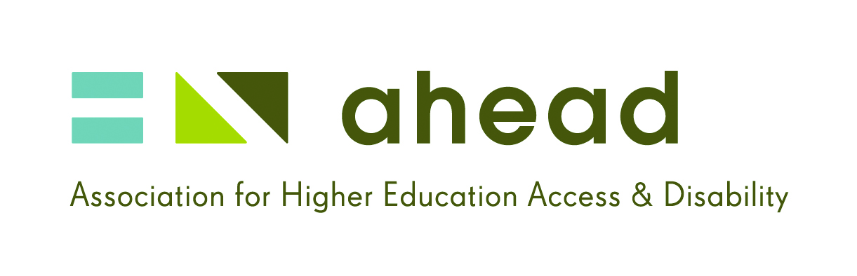

Everyone is talking about Mental Health but employers are STILL IN DENIAL!!
“Mental health is on all our minds these days…but what is a mentally-healthy workplace?!!”
Agenda
9.30am Arrival & Registration & Tea/Coffee/Pastries
10.00am Welcome & Introduction
10.20am Debate facilitated by Carol Hunt
Andrew Blair
Head of HR Business & Consumer Banking, Bank of Ireland
Conor Cusack
Irish Sportsperson
Scott Ahern
Outreach & Partnership Officer, SeeChange
Tom Lenihan
President, Trinity College Dublin Student Union
12.20pm Closing & Thanks
12.30pm Close

Event Location & Directions

This event is being held in ESB Head Offices, Lwr Fitzwilliam Street, Dublin 2.
The location of the venue is on the corner of Merrion Square East and South in Dublin city centre. Information about car parking and public transport is outlined on this interactive map: CLICK HERE
- Car Parking:
  - On-street car parking is available directly outside ESB Head Offices and all around Merrion Square. (LINK)
  - There are two nearby car parks available, Gratten Street and Dawson Schoolhouse Lane, which charge €2/€3 per hour respectively. (LINK)
- Public Transport:
  - The best way to travel to the venue is by Dublin Bus towards Merrion Square or towards Lower Baggot Street. To find out what number bus suits you best, check out the Dublin Bus website by searching on the map. (CLICK HERE)
  - If you are arriving from Hueston Station, you could get the Luas (Red Line) to ISFC, cross over the River Liffey to Lwr Fitzwilliam St. It is approximately 15 minutes’ walk. If you are arriving from Connolly Station, you could also walk to Lwr Fitzwilliam Street which would take about 20 minutes.
- Refreshments:
  - On arrival, there will be tea/coffee and pastries available.

Speakers Biographies

Carol Hunt is a journalist/columnist with the Sunday Independent/Herald and a regular contributor to debate on Irish radio and TV.

Andrew Blair has worked in Human Resources for over 25 years in a number of roles in Ireland and England. His current role is Head of HR Business and Consumer Banking for Bank of Ireland. Andrew has qualifications in Psychology, Sociology and Business. Andrews's interest in disability is through his work and ensuring all staff and potential staff are treated appropriately during recruitment & employment. He has previously worked with The Mary Hare School for the Deaf in England and the WAM (Willing Able and Mentoring) Programme in Ireland. He is also on the Board of AHEAD.

Conor Cusack hails from the town of Cloyne, situated in the East Cork region. He has played hurling with his native GAA club since he was five years of age and has also represented Cork at Senior Inter County level. He works for a large multi-national Medical Devices company in Cork as a Project Engineer. The sports star recently wrote a blog post about his experiences with depression and the impact it had on his life. The positive blog post resonated with a huge number of people, and he was invited on to Prime Time to talk about his story. Conor has in the past few weeks being transformed from a club hurler to a national figurehead, with numerous appearances on TV and radio. His desire is that his story will give hope and comfort to others that may be struggling and help to reduce the stigma and taboo associated with Mental Health issues. Conor’s message is that depression and mental health problems can and do affect us all in some way, whether it be with ourselves, a family or community member, a friend or work colleague. He emphasises that reaching out and seeking help is not a sign of weakness but a tremendous act of courage and strength.
Scott Ahern is 26 years old and works for See Change, the national mental health stigma reduction partnership, as their Outreach & Partnership Officer. Scott is a UCD History graduate from Clonmel, Co. Tipperary. During his time as an undergraduate, Scott was very active in student life having participated in societies such as Literary & Historical society and the Law society. He was active in UCD Students’ Union holding the position of Disability Rights Officer, and two successful terms as Welfare Vice-President. He also went onto serve as the national Welfare Officer with the Union of Students in Ireland (USI). Scott co-ordinates the ‘Please Talk’ campaign that is now based in 35 HEI’s across Ireland and Northern Ireland. In all of these roles, Scott held mental health as a priority.
Tom Lenihan is the President of Trinity College Students' Union and suffers from depression. He has spoken about mental health issues in the media on a national level.

