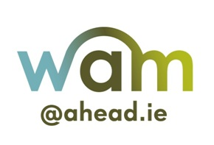

The AHEAD WAM Programme

Civil Service Placements 2019
Application Form

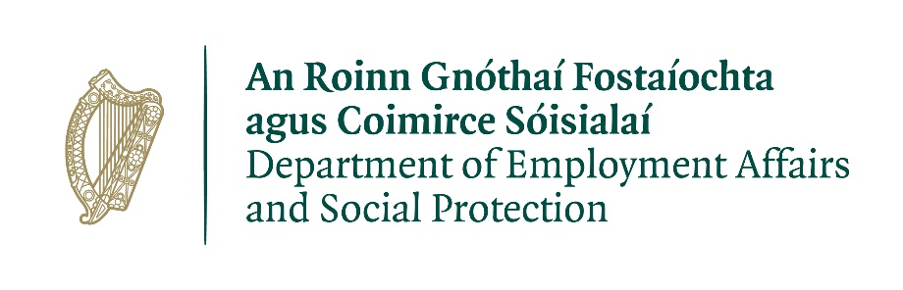
IMPORTANT NOTE: Please note that by completing this form you are confirming that you have a disability and are therefore eligible to apply to participate in WAM.
- This application is for full time, 6 month placements and as with all Civil Service positions is for national reach.
- The application is for Executive Officer Level however if you have an interest or specialism, it may be beneficial.
- A panel will be formed and if successful you will be available for selection until the next panel is formed or should AHEAD disband the panel. Being on the panel does not always automatically mean a placement.
Please ensure you fill out all of questions asked.

Personal Details
First Name
Last Name
Address Line 1
Address Line 2
City
County
Personal Email Address
Mobile Phone Number

Please answer Yes or No to the following questions:
Do you have a primary honours degree, at least Level 8 on the National Framework of Qualifications before 30th June 2019
Are you a citizen of the European Economic Area (EEA)?
Have you completed a WAM Placement in the Civil Service previously, if so when?
Are you a permanent employee in the Civil Service?
Are you available and ready to undertake a full-time, graduate level work placement from July 2019?

Educational Qualifications
Please outline your educational history to date.
Qualification
Year Obtained
Subjects Taken
Higher Education Institution
Final Grade Achieved

Qualification
Year Obtained
Subjects Taken
Higher Education Institution
Final Grade Achieved

Please enter any other additional education qualifications below:

Employment History
Please outline your most recent paid/unpaid or voluntary work experience to date.
Position
Organisation
Dates
Description

Position
Organisation
Dates
Description

Please enter any other additional work experience below:

Experience, Skills & Competencies
Please give examples from your own experiences that best show your abilities in relation to the following competencies below. You can include experiences from education, paid employment, voluntary work or leisure activities.
Please take the time to compose your answers very carefully.
A WAM Civil Service work placement is at Executive Officer Level and as such demands
- IT and Administration skills
- Project Management skills

Relevant Skills (please refer to above list):

Analysis & Decision Making: (min 200 words)

Delivery of Results: (min 200 words)

Motivation/Commitment to the Role: (min 200 words)

Work Placements
In the area below, you will find details of the disciplines and geographic locations that placements are currently available through the AHEAD WAM Programme. These are a general overview of the disciplines related to the placements on offer. All placements require good Microsoft Word & Excel skills & contain administration work.
Please specify a Geographic Location by marking X for your preference
Geographic Location | Mark with an X
Dublin only
Connacht
Leinster
Munster
Ulster
Anywhere
Preferred Location

Please indicate by marking X if you have the knowledge/experience in the following areas
Discipline | X Qualification | X Experience
Arts
Business/Finance/Accountancy/Economics
Computer Science
Human Resources
Law
Science
Social Science
Statistics
Offers of a placement will be allocated according to the panel and as appropriate your experience and preferences. However as this is a general recruitment process your preferences may not be facilitated.

Terms & Conditions
- Please read the supplementary information pack for important additional information before submitting your completed application.
- Placements are full-time, paid, mentored and for a period of up to 6 months duration. Hours of attendance will be fixed from time to time but will amount to not less than 43 hours 15 minutes gross per week. The successful candidate will be required to work such additional hours from time to time as may be reasonable and necessary for the proper performance of his/her duties subject to the limits set down in the working time regulations
- The AHEAD WAM Programme is a competitive recruitment process. Application screening, interviewing and candidate selection are conducted by the employers NOT the WAM Programme. Therefore we cannot guarantee an invitation to interview or an offer of placement.
- The offer of a placement is on the condition that the successful applicant completes a needs assessment. The needs assessment process is a consultative process between WAM, the successful candidate and the employer. The aim of the needs assessment is to identify what, if any, reasonable accommodations will be required on placement. Please note that in order to facilitate a thorough needs assessment process you will be asked to disclose your disability.
- Applicants must successfully complete and be placed on the panel for selection as placements arise. The number to be called forward will be determined by PAS.
- In certain instances positions may arise where specialist skills or experience is required e.g. accounts, language skills, etc. Suitable candidates may be selected for the purpose of filling such vacancies.
- Separate selection procedures may be conducted to determine suitability for particular posts / location(s).
- The Association for Higher Education Access & Disability (AHEAD) regards the lawful and responsible treatment of personal information as very important and therefore ensures that this data is collected, processed, stored and disposed of with this in mind. To this end, AHEAD endorses the principles of Data Protection, and is in full compliance with the EU General Data Protection Regulation 2018. Some or all elements of the selection process may be undertaken by third parties. In such circumstances it will be necessary for your information to be shared between AHEAD and these parties in order for your application to be processed.
- Information provided on this form will be utilised in the following ways:
  - To administrate and facilitate WAM work placements in a smooth manner;
  - Where information is provided in relation to reasonable accommodation, this information will be passed on to the relevant employers in order to provide the necessary supports at interview;
  - Some elements of data provided may be used, in aggregated and anonymous form, for research/statistical purposes in order to inform our funders and other interested parties of WAM’s achievements and progress.
- There is no guarantee of a permanent position with any of the employers as a result of undertaking a WAM placement. It is envisaged that streams of qualified individuals will be established from which vacancies may be filled. Qualification and placement on a panel is not a guarantee of appointment to a position. Please note that once an offer of appointment has been accepted a candidate will be removed from other panels.
- The admission of a person to a competition, or invitation to attend interview, or a successful result letter, is not to be taken as implying that the PAS is satisfied that such a person fulfils the requirements.

Specific candidate criteria
Candidates must:
- Have the knowledge and ability to discharge the duties of the post concerned
- Be suitable on the grounds of character
- Be suitable in all other relevant respects for appointment to the post concerned;
- If successful, they will not be appointed to the post unless they:
  - Agree to undertake the duties attached to the post and accept the conditions under which the duties are, or may be required to be, performed
  - Are fully competent and available to undertake, and fully capable of undertaking, the duties attached to the full time position
- If you previously completed a placement in the Civil Service you cannot apply for a second placement however you may apply for other WAM placements.
- You cannot apply for a WAM placement in the Civil Service if you are already a current permanent employee within the Civil Service.
- You must disengage in political activity for the duration of the placement.
Candidates' Obligations:
Candidates must not:
- knowingly or recklessly provide false information
- canvass any person with or without inducements
- personate a candidate at any stage of the process
- interfere with or compromise the process in any way
- The above represents the principal conditions of service and is not intended to be the comprehensive list of all terms and conditions of employment which will be set out in the employment contract to be agreed with the successful candidate.
I agree to the above terms and conditions:
Please type your name in the section below;
Signed: Date:

Please submit this completed application form using your online account on our WAMWorks database at www.ahead.ie/wamworks before the closing date.

