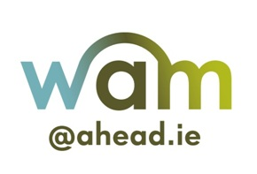

The AHEAD WAM Programme

Civil Service WAM Placements 2022
Application Form

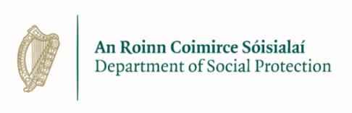
IMPORTANT NOTE: Please note that by completing this form you are confirming that you have a disability and are eligible to apply to participate in The WAM Programme.
- This application is for full time, 7-month Civil Service WAM Placements and as with all Civil Service positions, they may arise in any location.
- The application is at Executive Officer level however if you have an interest or specialism, it may be beneficial.
- A panel will be formed and if successful you will be available for selection until the panel is disbanded. Being on the panel does not always automatically mean a 7-month Civil Service WAM Placement
Please ensure you fill out all of questions asked.

Personal Details
First Name
Last Name
Address Line 1
Address Line 2
City
County
Personal Email Address
Mobile Phone Number

Please answer Yes or No to the following questions:
Do you meet all of the eligibility criteria specified in the accompanying Information Pack?
Please check the Information Pack for full details.
Are you available and ready to undertake a full-time, graduate level, 7-month Civil Service WAM placement commencing on 1 July 2022?
Have you registered a candidate profile on Public Jobs website and applied for this campaign?
If not, please read the Information Pack for further details.

Educational Qualifications
Please outline your educational history to date. Please note, the minimum requirement for 7-month Civil Service WAM Placements is a Level 8 qualification recognised on the National Framework of Qualifications.
Name of Qualification
NFQ Level
Year Obtained
Subjects Taken
Higher Education Institution
Final Grade Achieved

Qualification
NFQ Level
Year Obtained
Subjects Taken
Higher Education Institution
Final Grade Achieved

Please enter any additional educational qualifications below (max 100 words):

Employment History
Please outline two of your most recent or relevant paid/unpaid or voluntary work experience to date.
Position
Organisation
Dates
Description

Position
Organisation
Dates
Description

Please enter any other additional work experience below: (max 200 words)

Experience, Skills & Competencies
Please give examples from your own experiences that best show your abilities in relation to the following competencies below. You can include experiences from education, paid employment, voluntary work or leisure activities.
Please take the time to compose your answers very carefully. Each section should be a minimum of 150 to a maximum 200 words in length.

IT & Administration / Project Management Skills:

Analysis & Decision Making:

Delivery of Results:

Motivation/Commitment to the Role:

Geographic and Discipline Preferences
In this section below, you will find details of the geographic locations and disciplines that 7-month Civil Service WAM Placements may be available through the AHEAD WAM Programme. However, due to Covid-19, they may be remote working or operate on a hybrid model between on-site and off-site.
Please specify a Geographic Location by marking X for your preference
Geographic Location | Mark with an X
Dublin only
Connacht
Leinster
Munster
Ulster
Anywhere
Preferred Location | (please specify)

These are a general overview of the disciplines related to the 7-month Civil Service WAM Placements that may be on offer. Please indicate by marking X if you have a qualification or experience in the following
Discipline | X Qualification | X Experience
General/Arts
Business
Finance/Accountancy
Economics
Statistics
Engineering
Agricultural Science
Social Policy
Computer Science
Human Resources
Chemistry/Applied Science
Law
7-month Civil Service WAM Placements will be allocated according to the panel and as appropriate your experience and preferences. However as this is a general recruitment process it is possible that your preferences, if offered a 7-month Civil Service WAM Placement, may not be facilitated.
I confirm that I have read and agree to the Terms and Conditions specified in the accompanying Information Pack and consent to my personal data in this form being shared with the Public Appointment Service and relevant Civil Service employers in order to facilitate the management and administration of the 7-month Civil Service WAM Placement process.
Please type your name or insert your signature in the section below;
Signed: Date:

Please submit this completed application form using your online account on our WAMWorks database at www.ahead.ie/wamworks before the 9 March 2022.

