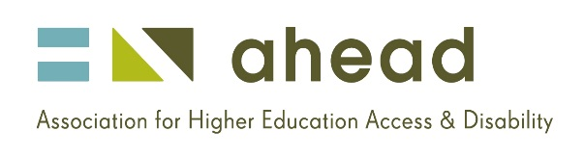

AHEAD Vacancy - Temporary WAM Project Worker
AHEAD, the Association for Higher Education, Access and Disability, is a national centre of expertise on disability in education and employment. It supports students with disability their parents and career advisors to access higher education and to build careers of their choice. It works and supports Irish Employers to build disability confident workplaces so that graduates with disabilities can enjoy the same employment opportunities as all other graduates.

Temporary Project Worker
- Applications are invited for a Temporary post of Project Worker to work with the Willing Able Mentoring (WAM) project supporting graduates with disabilities into work placements. Position is based in Blackrock, Dublin.
Reporting to the Project Manager, the successful candidate will demonstrate the ability to work as part of a team, to administer and evaluate the WAM programme by way of maintaining records and preparing reports, work collaboratively with a network of employers and have good organisational abilities. The job will provide opportunities to work on own initiative in a dynamic team supporting Irish employers to build disability confident workplaces.

QUALIFICATIONS
A recognised third level qualification in broad area of Education, Social Work, Social Care, or another related discipline is desirable – however knowledge about the higher education system in Ireland is necessary.
A full job specification can be downloaded here - (MS Word) (PDF)
Please email a CV and cover letter outlining your interest in the position to Cass Horton -ahead@ahead.ie by close of business Tuesday 12th August 2014.

