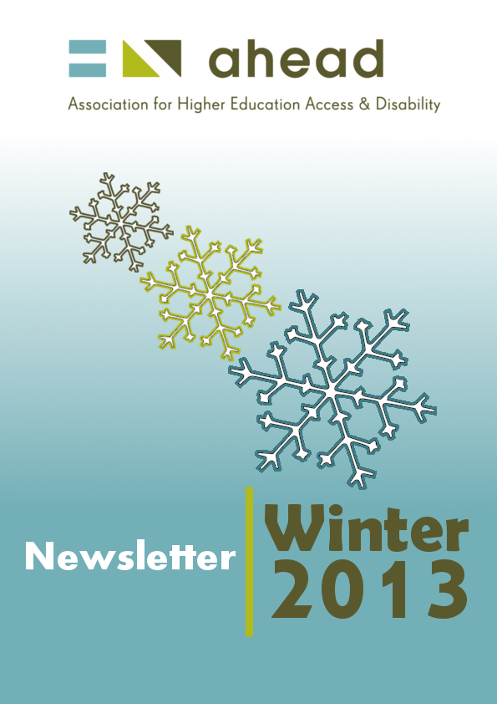

Inside this issue:
A Tribute to Patricia Kearney 3
Accreditation – A New Route to Quality Standards for Disability Services 4
Disability in the Health Sciences - A Summer School for Health Professionals Working with Students with a Disability 7
Experiencing Teaching and Learning assumptions at the National Gallery of Ireland 9
A Guide for Students with Disabilities on Professional Placement & Professional Planning Support in Trinity College Dublin 11
What Kino can do - Free software that aids screen reading 11
Disability Friendly Apps For you to consider! 14
AHEAD and the transition from college to the Workplace - Employer/Student Events 16
Innsbruck Conference 2013 – Some personal thoughts 17
NOTICEBOARD – TALK OF THE TOWN 19

A Tribute to Patricia Kearney
Written by Ann Heelan, Executive Director, AHEAD
Patricia Kearney’s career spanned work in the fields of science and academic teaching career before turning her attention managing disability support services for over 290 students with disabilities and specific learning difficulties in Athlone Institute of Technology. They currently represent over 4.5% of the total student population there and to put it into context when Patricia started in Athlone, there were less than 20 students with disabilities in the college, (AHEAD Research 1998). Patricia did not walk into a ready-made job: she made the job her own and was key in evolving Disability Support Services and implementing Disability Policy on campus.
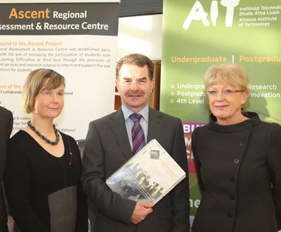
When Patricia became blind due to illness, she turned her skills and knowledge of working in higher education to the benefit of other students with disabilities of all sorts and developed expertise in the area of Human Rights and the inclusion of students with a range of impairments in all aspects of higher education. Her passion for her area of work came through in everything she did and her work went from strength to strength, developing excellent disability support services in Athlone Institute of Technology and highly innovative projects with Galway-Mayo IT and Letterkenny IT in the areas of needs assessment and getting supports right for students.
She was no push over though and could be very direct in her dealings with people, reserving her more acerbic wit for those who she perceived to discriminate against her students or those who were slow to provide support to students with different learning needs.
At a recent visit to the International Disability in Higher Education Conference in Innsbruck in July in 2013 she came back re energised saying that she had seen a huge gap that needed improving and that she must do something about the inclusion of students with disabilities in clubs and societies. This approach was typical of Patricia, who with her ‘can do’ attitude, took a strategic approach to the problems student might have.
Picture 1 shows Patrician Kearney (left) with Ann Heelan (right) and president of AIT, Prof. Ciarán Ó Catháin
As a colleague Patricia was great fun, always up for a laugh and brought her sense of humour to her job. We enjoyed her company in Innsbruck and my last memory of Patricia is her refusing to go home without one last nightcap in the bar and good naturedly calling us “a load of wimps” for attempting to slip away.
Patricia sadly passed away in September 2013 and her energy, warmth and commitment to improving the college experience of students with disabilities will be sadly missed. All the staff of AHEAD would like to send our sincere condolences to her family, colleagues and the countless students she helped across her career.
Rest in Peace Patricia, Ann Heelan, AHEAD

Accreditation – A New Route to Quality Standards for Disability Services
Written by Alan Hurst, Independent Consultant
Unlike those working alongside them – colleagues such as those in counselling and careers – there remains a gap in providing recognition for the achievements of staff working in disability services in post-school education. Some organisations (e.g. AHEAD) and institutions have created their own programmes, often at a basic level to introduce staff to aspects of working with disabled students and often available on-line. Some years ago, the universities of Central Lancashire and Plymouth in the UK devised a portfolio of taught courses to meet the needs of both new and inexperienced staff and also those of the more experienced practitioners. At one stage, the two programmes were brought together and validated successfully by quality assurance procedures in both institutions. Sadly, for reasons, such as the costs to participants in terms of time and expense, the programme is no longer available. Now, a different approach has been established by the National Association of Disability Practitioners (NADP) the association of professionals working in the specialist field. This involved a shift in focus away from the provision of initial training and further continuing professional development towards the recognition of already-existing practices and their accreditation.

The NADP Accreditation Scheme: Basic Features
What has been put in place is a structure and a procedure within which accreditation can take place. This offers individual practitioners a route to formal, external recognition that they have reached a certain level of professional practice. It is not a course or programme of study leading subsequently to a qualification. The scheme has a number of key features:
- it is easy to manage in terms of how it is structured and organised;
- it is efficient and effective in terms of use of time by all those involved;
- it is cost-effective and provides excellent value-for-money;
- it is credible both within the NADP and also within the world outside the association;
- it is comprehensive in trying to bring together practitioners from a variety of backgrounds – psychologists, academics, social workers, occupational therapists etc.
- it is rigorous and is not a “rubber stamping” or “tick box” approach; rather it seeks to balance being appropriately demanding and challenging with being realistic in terms of what can be expected of working applicants;
- it supports the exchange of knowledge and the dissemination of information and innovation, thereby helping practitioners develop their knowledge and skills and by promoting collaboration;
- it contributes to the development of professionalism and to wider and greater recognition for the status, roles and responsibilities of staff working with students with disabilities in post-compulsory education and training;
- it encourages critical reflection by practitioners in both their own attitudes and actions and also those of others.

Applying for Accreditation
The NADP Accreditation Scheme has two levels: Accredited Member and Senior Accredited Member. Everyone has to secure Accredited Member status in the first instance. Application for accreditation involves enrolling on the scheme, payment of a fee to cover administration costs, and submitting work under three themes:

- Working with students with disabilities with special reference to the NADP Code of Practice, and could take the form of case studies of individual students or the impact of a particular kind of impairment on learning;

- Continuing professional development, which could be an analysis of the applicant’s own needs and how they might be met or a consideration of a staff development programme for non-specialist Faculty colleagues;

- A critical reflective journal containing a selection of activities for a week’s work.

- In addition applicants must submit one additional item chosen from three further themes: disability, society and education, institutional policies and procedures, and quality assurance.

For those progressing subsequently to Senior Accredited Member status, all these additional items must be submitted plus one more on a topic of the applicant’s own choosing and which does not repeat any of the other five topics. A second reflective journal is also required.
Normally, all submissions are made electronically with alternative formats considered by request. Submissions should be between 500- 750 words with a maximum excess of 10% (i.e. 825 words) or equivalent. The reflective journal is treated slightly differently in that in addition to submitting a sample weekly diary/log, applicants have to provide a commentary which should be no longer than 600 words on two items chosen from their diary.
Regarding the content of applications, the Accreditation Panel is looking for content which can be categorised under two major headings:
a) A range of knowledge, skills and professional values with reference to the following:
- Relevant recent legislation, policies, codes of practice
- Disability theories and concepts, the impact of impairment on learning
- Relevant research
- Internal institutional systems
- Funding mechanisms/sources
- Course design/course structures
- Learning approaches
- Academic assessment strategies
- Support systems, both human and technical
- Information sources

Quality measures and quality enhancement
b) A range of attitudes and activities drawn from the following:
- Aspects of working 1:1 with learners
- Co-operation and team-working with others
- Contribution to needs assessment
- Liaison with external agencies
- Devising and promoting inclusive policies and practices
- Involvement in disability education for staff
- Participating in and contributing to key committees/groups both within and outside the institution
- Recognition of roles, responsibilities, boundaries and personal competence

Accreditation and Wider Credibility of the Scheme
The NADP has established an Accreditation Panel to review applications and make decisions on whether they reach the required standards. It has face-to-face meetings on at least two occasions during each academic year although in keeping with the desire for efficiency and effectiveness, most of the work is completed using electronic means.
Applications are forwarded anonymously to two members of the panel, one of whom is designated first assessor and who is then responsible for compiling and creating feedback to the applicant. The decisions available to the assessors are to deem items as meeting the criteria or to return the items(s) for further work and subsequent resubmission. To support applications all applicants are informed that they have been allocated to a mentor.

In closing, whilst four years might seem to have been an excessively lengthy development phase, the fact that Accreditation Scheme has been implemented and is working well currently is a major achievement. However, everyone does need to remember that the procedures, practices and processes are relatively untried and tested and so there are likely to be further points needing to be addressed. Given the universality of concerns of those working with disabled students, establishing similar schemes in other countries should be a distinct possibility.
More details can be found on the NADP website www.nadp-uk.org

Disability in the Health Sciences - A Summer School for Health Professionals Working with Students with a Disability
Written by Phil Halligan & Frances Howlin, UCD Disability Support Team
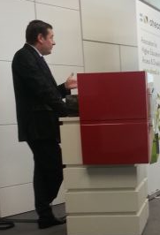
Ahead, in conjunction with UCD School of Nursing, Midwifery and Health Systems (UCD/SNMHS), held their first unique Summer School for professionals supporting students with a disability in healthcare to share their learning, network and forge alliances for the future. The three day Summer School was held in University College Dublin between the 27th to 29th August. Over the past few years, AHEAD and UCD/SNMHS have made a significant number of commitments and implemented initiatives for supporting nursing and midwifery students in clinical practice. This year, they extended these commitments to include all health care disciplines (Medicine, Radiography, Speech and Language therapist, Occupational Therapy, and Physiotherapy) who have responsibility for including students with disabilities in the Health Professions, including clinical placements.
The Summer School offered an outstanding opportunity to open a dialogue about the inclusion of a diverse range of students on placement in Healthcare, especially students with a disability. Overall, and collectively, participants at the Summer School considered their approach to students learning and assessment whilst on clinical placement, reviewed common issues, and debated the challenges they perceived to be facing their students with disabilities in these contexts. Throughout the three days, participants reflected on how current support structures and procedures could be changed to improve supports for their students by aligning their current work and support strategies with the principles of Universal Design from a health care perspective.
Participants in attendance were from several third level institutions, healthcare and disability support services, including Irish hospitals, Hospital Services Executive (HSE), and universities across Ireland, England and Scotland. Invited presenters covered a range of topical issues that focused exclusively on supporting students on clinical placements in the field of health care. Overall the groups created a very inspiring and productive summer school that managed to execute the tasks planned for the event while also generating some practical and new ideas for developing ways of providing further support to students seconded on placements in a variety of clinical settings.
On the first day, Ann Heelan (CEO of Ahead), welcomed and opened the summer school and introduced participants to the overall objectives and the associated evening networking activities. Participants were encouraged to introduce themselves to the group, briefly outline their area of expertise and expectations to focus the organizers and assist in optimizing the event outcomes. Leadership ‘Doing the right thing versus doing things right! was a central theme that flowed throughout the summer school. Dr. Phil Halligan emphasized, through her knowledge and expertise of leadership practices, that we all need to ‘lead’ the way in supporting our students in healthcare if we are truly to claim to have a diverse and an inclusive educational system for all. Following on from Phil, Barbara Waters (Disability Consultant), posed interesting case studies and dilemmas to participants about ‘Fitness to Practice and maintaining standards in an uncertain world’. This was directly followed by Katie Ridge, Barrister of Law teasing out the ‘The Law: A psychological contract?’ and then Ann Heelan introduced a session on Teaching, Learning and Universal Design taking into account that you cannot make assumptions based on what you think you know! For more on that section, see Marian McCarthy’s piece below. Participants were then treated to a fun evening literary tour of Georgian Dublin that allowed them to wind down and get to know each other. As Dublin is one of the literary capitals of the world, participants enjoyed being guided to the birthplaces of James Joyce and the Nobel Prize for Literature winners William Butler Yeats, George Bernard Shaw and Samuel Beckett. Following the historical update, all weary participants finished their first day with food and drink entertainment in Dublin’s fair city.
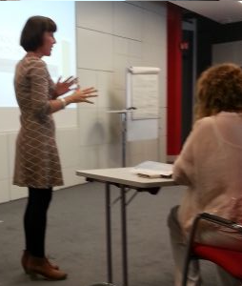
Days 2-3 of the event focused on the processes of disclosure and assessment where Mary Quirke (Assistant Director of AHEAD) provided invaluable insights, from her experience and knowledge, about the student perspective titled ‘The Student: A Certain or Uncertain Future, Assessing the Need for Accommodation – a systematic approach’. Mental health was the next area addressed because, as Dr Cian Denihan, Consultant Psychiatrist, UCD Student Centre indicated, it is often considered to be ‘the big elephant in the room’. Dr Denihan focused on addressing and recognizing student Mental Health difficulties on Clinical Placement and provided insights from his professional background and experience of working with students as to how staff supporting students could start the conversation about mental health issues and more importantly, where support staff responsibilities are positioned at the end of the day. The concept of ‘Disclosure and how to create a relationship of trust’ was provided by the theatrical group Adaptas which was highly interactive and fun.
The final day of the summer school began to come to a close with Helen Carroll, Learning Support Tutor, from Dublin Institute of Technology introducing the most common disclosed disability in many third level institutions – ‘Dyslexia – so what are the issues really?’ Helen provided a detailed account of the psychological assessment process that students have to complete in advance of their registration and this also provided further insights to participants/assessors when agreeing suitable accommodations for each student with a disability. Before completion, James Northridge (UrAbility) provided an excellent demonstration on the many tools available that assist students with disabilities, mainly dyslexia, in many health care environments.
The summer school concluded with an opportunity for all participants to brainstorm the future - where we go from here, future support and networking. Before departure, participants were invited to complete an evaluation of the event and rated the summer school as excellent for content, delivery and for overall organization. In addition, participants rated the summer school as a good opportunity to review national and international good practice. This illuminated the impact of different methods used by teaching and support staff who work with undergraduate students with disabilities and as a result a clearer understanding emerged about challenges facing professionals (both in the lecture theatre and the clinical setting) as they seek to maintain egalitarian standards and an inclusive healthcare environment. Considering the excellent feedback and interest, another Summer School is being considered in summer 2014. One thing for certain, the Summer School has given participants’ great opportunities to learn, network and have some fun!

Experiencing Teaching and Learning assumptions at the National Gallery of Ireland
Written by Dr Marian McCarthy and AHEAD Summer School participants
At 15.15, on the 27th August 2013, Day 1 of the UDL Summer School for Health Professionals Working with Students with Disabilities, we left the UCD campus in a fleet of taxis bound for the National Gallery, where our workshop on exploring our assumptions regarding teaching and learning was to take place. Prior to departure, participants had been briefed on Howard Gardner’s theory of Multiple Intelligences (MI), which claims that we have a variety of intelligences, rather than one generic intelligence or intelligence quotient (IQ), which we bring to bear on our problem solving across the disciplines and in real life contexts. In line with the promise of the abstract for this workshop, the theory was then aligned with the central concepts of Universal Design for Learning (UDL), which also underlines the importance of having multiple means of representing knowledge, of engaging students and of providing opportunities for multiple ways of expressing that knowledge, if all students are to have the opportunity to make the most of their learning.
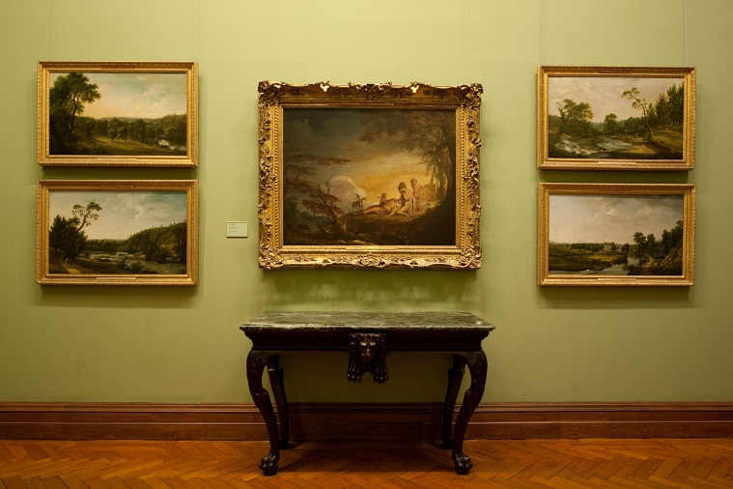
Conducting the workshop in the Gallery provided an appropriate setting to engage with MI and UDL principles: All participants were in a new classroom space –that of the gallery- which re-defined the learning experience, literally opening it up to new ways of representing what learning is (through experiencing the art works), new ways of engaging with the work (through close observation of art, defined by the variety of Entry Points to learning provided by Gardner’s theory) and new ways of expressing the experience (through negotiated, discursive learning defined in the group work experience of peer observation and discussion).
In this Project MUSE approach, where museums and galleries are harnessed as sites that provide us with valuable learning experiences, participants were invited firstly to explore the exhibition in the wing devoted to Modern Irish Art for themselves, in groups of five or six. Participants were then encouraged to select one painting which they were all happy to work on and to spend thirty minutes using a variety of ways in (or entry points) to the paintings, such as narrational ways into the work through story, or experiential ways in through role play, or social ways in through group work and discussion and so on. Gardner names at least seven ways into any learning experience and invites teachers to explore these over time; hence, the focus on a variety of ways of representing knowledge and of engaging students in their learning. Such approaches inevitably lead to students’ multiple ways of expressing their learning in the light of the variety of their engagement with the learning experience.
Reactions to this process were positive and multifaceted. Participants commented on the fact that they had never spent such a long time in front of one work of art. Such a point gave rise to discussion regarding the time needed to really explore a topic, in this case a painting, and led to discussion regarding deep, as opposed to surface, approaches to learning. It was also interesting that groups chose a variety of paintings; a range of portraits, for example, were chosen. One group examined Colin Davidson’s portrait of Michael Longley – which they saw as a dramatic portrait with strong brush strokes and a larger than life effect– like that of the poet.
Another group focused on Yeats’ Men of Destiny and its characterising of the heroic in its bold use of colour. Other groups worked on the new exhibition in this wing entitled The World of Performance: Dance, Theatre and Song and its portraits of actors like Muriel Brandt’s Micheál Mac Liammóir and Sean Keatings’ Jimmy O’Dea. Regardless of the work chosen, what was common in discussion afterwards, over coffee in the gallery restaurant, was that no two people interpret the work in the same way; each brought a unique perspective to the work, which was borne out of their own experience of life and of the disciplines in which they were immersed.
Another key point that emerged was the nature of and the effect of the group dynamic: as a member of the group it became important to listen to the other and to take on new perspectives. Participants also noted that though there were divergent views there was also coherence and common threads in the discussion that emerged. The longer the group worked together the more they were able to listen to and accommodate each other’s perspectives. In a nutshell, exploring a work of art on its many levels is another way of talking about and experiencing the meaning and implications of a universal design for learning approach. The gallery provides us with that magic space where we can begin again to experience learning in all its richness, complexity and variety.

A Guide for Students with Disabilities on Professional Placement & Professional Planning Support in Trinity College Dublin
Written by Declan Reilly, Disability Support Services, TCD
The Disability Service in Trinity College Dublin has produced a placement planning guide for students with disabilities on professional courses. Declan Reilly, Disability Officer in Trinity, explains that there are increasing numbers of students with disabilities across the range of professional courses in Trinity College and recent feedback from students and staff has highlighted a shortage of guidance and information in relation to how best to provide supports and accommodations for this student group. The development of this professional placement guide is part of an overall strategy within the Disability Service to support students with disabilities on their journey into professional courses, through placement and on to employment.
The guide supports disclosure and encourages students to contact the Disability Service to explore what supports and accommodations may be relevant for them. A central part of the support process is professional placement planning. In advance of placements beginning, students meet with academic, placement and Disability Service staff to discuss the needs of the student and develop a plan of action. The outcome is an agreed set of reasonable accommodations that will operate on site, during the placement. The guide deals with issues such as disclosure, confidentiality, fitness to practice and reasonable accommodations. It provides step by step guidelines on how to communicate and share information. The key message for students is that we want to encourage disclosure through a supportive process that involves all parties concerned. The key message for staff is that students with disabilities are succeeding in greater numbers on professional courses and that in the vast majority of cases, their support needs are small and easily identifiable.

What Kino can do - Free software that aids screen reading
Written by Oliver Whelton, Learning Support Tutor, UCC
Kino is a screen dimming tool that enables the user to select an area of the computer screen to be displayed in a viewing pane using a crosshair ‘cut’ while darkening the rest of the screen from full transparency to total black. This darkened area can be controlled with a slider control at the right side of the screen so that only the selected area you have chosen remains visible. The amount that is visible at any one time is resizable at the wish of the user. Controlling the ‘other’ screen when reading the information is unhindered as it would be normally as you scroll down the webpage or document. Kino (Isolator is the Mac equivalent) provides ease of use with a simple green symbol which allows the program to be minimised to the desktop toolbar at any time and can reappear onscreen whenever needed. It can also be closed completely by clicking the red X symbol.
The user can adjust the opacity from full transparency to dimmed grey to full black with a slider control at the right side of the screen. Its many uses include hiding desktop clutter and other distractions during on-screen activity such as tasks, presentations or video playback and Kino can be run from any USB memory stick or Flash drive making it a completely portable application.

Why use it?
With the growth of online reading material alongside the writing and submission of assignments, as well as class teaching via interactive whiteboards, the need for software which promotes better reading and comprehension, while reducing difficulties of concentration for most and visual stress for some, becomes essential.
Multi-modal teaching styles can result in unintentional overload of sensory information and reading concentration and comprehension difficulties often mean that not all students can embrace multi-sensory teaching/learning to its fullest. Authors such as Hanbury (2005) have highlighted the difficulties for those with autism who are susceptible to sensory overload inducing states of either high excitability or high anxiety, while students affected by visual stress syndrome and Irlen Syndrome can be assisted by freeware like Kino, especially when it is used in conjunction with associated screen masking software.
The ability to concentrate attention on a small amount of text or screen activity within a document, website or program onscreen at one time is of great value for children and adults with difficulty focusing and enhances comprehension. Onscreen content such as journal articles with side by side columns of text that must be read top down can be isolated and masked a column at a time by the use of the crosshairs reducing this difficulty.
Summary of benefits:
Benefits | How this can help
Concentrated focus | Concentrates the minds of the students reading off or being taught via Smartboard or on a smaller screen e.g. monitor or laptop. This is particularly helpful for students with ADHD, autism, reading comprehension difficulties.
Taxiing before take-off | Larger amounts of information can be placed onscreen but only revealed to the student as needed which reduces the effects of information overload.
Reduced disruption | For teachers it can keep student(s) focused and up to speed on more concentration heavy tasks onscreen resulting in less frustration and potential disruption.
Improved screen reading | An aid to students who are visually impaired as it allows for easier screen reading and also for completion of tasks related to onscreen activity
Step-by-step | Assists teaching on a step-by-step basis, e.g. the teaching of music or a song can be done on the basis of isolating specific lyrics onscreen, followed by the pitch and melody notation above them in lines of music.
Student focused | In one-to-one and Resource Teaching, it greatly reduces the need to have to point at the screen to keep a student on task while keeping a physical distance between teacher and student. This can be particularly important when working with students on the autistic spectrum.

Conclusion:
The use of digital technology in the classroom and at home in our teaching and learning is only going to increase but it also presents us with opportunities to alter our teaching pedagogies and ways of learning which must change in line with this movement. Doing so without a cost implication has been the motivating factor in writing this and forthcoming articles in a time of ‘doing more with less’.
In terms of teaching pedagogy, Kino, when additionally used in conjunction with a wireless track pad, allows the teaching experience to fully embrace the 21st century by providing complete freedom of movement rather than trapping a teacher at the top of the classroom trying to click a mouse or a keyboard to move onto the next task or rewind/replay a task. It allows for greater supervision of individual students in the room and allows for better monitoring and involvement.
Alternatives for Mac users:
Similarly for the Apple Mac, Isolator is a small, simple application designed to enhance your productivity by reducing visual distractions. Isolator can blur, cover up, or hide all other application windows. You can set blur intensity, background colour, opacity and fade speed.
Note:
As with all ‘free’ software or freeware, care should be taken when downloading and installing from third party websites so to avoid ‘subtle’ changes being made to computer settings or unwanted additional software being unintentionally installed. As with all software the decline option remains the preferred choice while taking one’s time will ensure successful installation.
Contributor notes:
Oliver Whelton works as a Learning Support Tutor at University College Cork. He has a research interest in technology in education and freeware in particular and provides information sessions both to the education sector and the public on a freelance basis.
For more information please email: teachingfreeware@gmail.com.
Download link: http://sourceforge.net/projects/pskino/
Images:
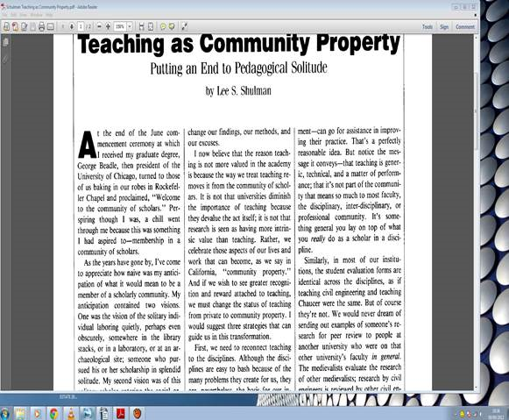
Fig 1: Viewing a document full screen without Kino
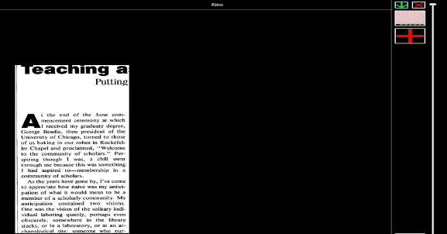
Fig 2: Using Kino to reduce screen to a more manageable amount of text

Disability Friendly Apps For you to consider!
Written and reviewed by James Northridge from UrAbility.com. UrAbility.com provide Assistive Technology training and products.
With greater choice now available, it is even more important that Apps are chosen to meet the specific needs of the user, the task and the context in which they are used. The market of apps for iPads is ever growing with over 650,000 apps on the market at the moment and currently over 20,000 of these apps are aimed at the educational market however the issue is how does someone know what apps to use in terms of education, more importantly which ones work and are they rated and fit for the purpose of education. More so, are these apps going to be useful for students with disabilities? We review below 5 useful apps for use with the iPad and given our feedback on its use.

Logo | Description | Price/link | Comment
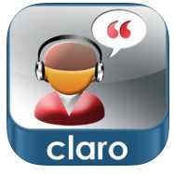 | ClaroSpeak is a high-quality text-to-speech reader capable of speaking any accessible text with a range of human-sounding high-quality voices. | £4.99  Link to buy | An easy to use application with good design and a range of high quality international versions (voices) available. Might be a good option to test the water in terms of text to speech, due to price.
 | Use Inspiration Maps to create diagrams, maps and organizers that help brainstorm, plan, organize and build thinking skills. | €8.99  Link to buy | Good app, again useful if students are using the software on desktop – can transfer and share mind maps between both. There is also a lite version available so you can try before you buy.
 | Dragon Dictation is an easy-to-use voice recognition application powered by Dragon® NaturallySpeaking® that allows you to easily speak and instantly see your text or email messages. | Free  Link to download | Great app for those that don’t have to be typing all day, it does require you to be connected to internet to use. Can be used for Facebook and Twitter messages also. A similar built in tool in now on the newer iPads, so ore useful for older versions.
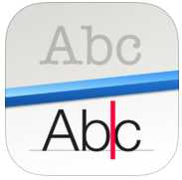 | Prizmo is a universal photo-based scanner app that lets you scan and recognize text documents, business cards, and images, and then export them as PDF/Text, vCard, or JPEG/PNG. | €8.99  Link to Buy | This app is fully compatible with VoiceOver, so you can take a photo of a document and then get it read back to you, they have 36 built in voices. Once the document has being scanned in, you can start editing.
 | Errands is a task manager with a pleasing design and is easy to learn and use. Crafted with a blend of basic and advanced features: Folders, Checklists, Task Images, Scheduling & Repeating, Alerts (alarms) | Free  Link to Download | Very simple app for students, sends you an alert for on-going tasks, so can be used in a college environment for assignments and class times etc.

AHEAD and the transition from college to the Workplace - Employer/Student Events
Written by the AHEAD WAM Team
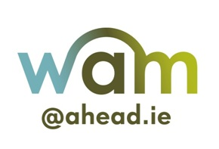
Employer Event - Strategies & Resources for Recruitment & Testing of Graduates with a Disability – Are you sure your testing is accessible?
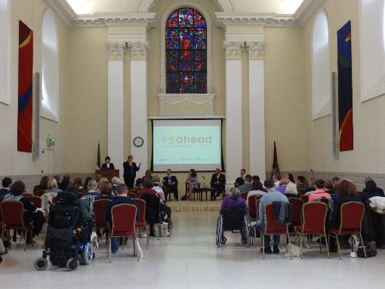
77 attendees registered for this event which was run in conjunction with Enterprise Rent-A-Car. The focus of this training event was on the assessment component of recruitment and the barriers posed by this process for many disabled applicants. Many companies use testing (in all its formats) as a component of the recruitment process and many more are moving towards using it.
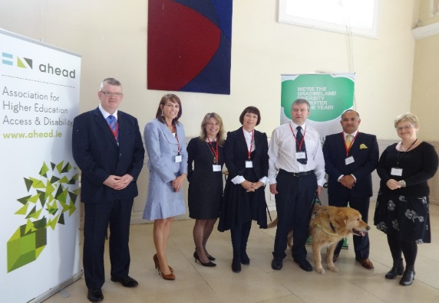
Event Title: Disability….Testing…..Recruitment
The event featured 5 panel members; Dr. Conor McGuckin; a psychologist and expert in psychometric testing, Leslee O’Loughlin; HR manager of Enterprise Rent-A-Car, Haaris Sheikh; CEO of Interesource Group Ltd, Louis Watters; WAM Graduate and Katie Ridge; barrister at law. A question and answer session was facilitated by Carol Hunt and guest speakers included Alan Chapman (Department of Social Protection representative) and George O’Connor (Managing Director of Enterprise Rent-A-Car). Panel Members with AHEAD Staff – Mary Quirke
Get AHEAD is a network of graduates with disabilities which aims to improve the work preparation and employment opportunities for graduates with disabilities.
GET AHEAD works to up-skill graduates with disability in preparing for work and enhancing their ability to negotiate these barriers through the recruitment and selection process, to secure full employment. It does this in an innovative way:

- Provides customised training workshops to graduates and students with disabilities
- Creates space for graduates to share their experiences and engage with employers, and forges partnerships with employers.
Students Get Ready for Work!
Get AHEAD hosted a ‘Get Ready for Work’ workshop, which was run in conjunction with the WAM Programme for graduates who had applied for a WAM placement. The workshops focused on preparing the graduates for interview by supporting them in recognising their skills and how best to demonstrate them during interview. The interview preparation workshop featured a HR guest speaker from our network of employers.
Interview Preparation Training Workshop
Michael Smurfit Business School, UCD, Blackrock, Dublin 4
In parallel with the WAM Programme’s recruitment for work placements with ESB, IBM and Dell Ireland, Get AHEAD ran an interview preparation workshop for those candidates who had applied for the companies outlined above. Leslee O’Loughlin, HR Manager from Enterprise Rent-A-Car, was our featured guest speaker who spoke about the employers’ perspective. 15 candidates registered to attend the workshop with 11 candidates present.
“Extremely informative, I learned a lot of new things.” (Comment from participating graduate)
Evaluations & Feedback
After the workshop, an evaluation was sent to those who attended the workshops to find out which aspects they liked the most and what would they like Get AHEAD to do in the future. From these evaluations; it’s clear that there is a demand for running these type of workshops, in particular outside of Dublin.
In the workshop, there were participants who had travelled from Galway, Limerick, Wexford and other counties. In addition, we received numerous requests to run more workshops for those who were unable to attend.

Innsbruck Conference 2013 – Some personal thoughts
Written by Alan Hurst, Independent Consultant
If 21 is still regarded as a significant birth-date, a coming-of-age, then the ninth triennial conference organised by the University of New Orleans and hosted by the University of Innsbruck in July 2013, marked the arrival of “adult status” for the event. Being one of just two or three people who have attended all the conferences since the first in 1992, perhaps it is time to reflect on this most recent event.
When the call for papers was made, it was very encouraging to receive proposals from almost 30 different countries, the biggest number I can remember. Inevitably, things happen between submission, acceptance and actual attendance at the conference, and some of those invited to lead sessions were unable to be present. That said, the sessions delivered involved 20 different countries and four of the five continents. It remains interesting to witness the different stages where policy and provision for disabled students have reached in the countries represented. Since 1992, it is clear that progress has been made but the universality of the remaining challenges faced by disabled students and those working to support them is striking – as is the lack of effective responses to meeting these challenges. We have yet to find answers to the same questions – a comforting thought.
To offer some flavour to these notes, I shall say something about the sessions I attended and which had an impact on me. There were many sessions about universal design but the one which impressed me most was by Bill Sharpton of the University of New Orleans with its focus on engaging members of teaching staff in various faculties in inclusive pedagogy. From the technology stream, the work done in Croatia by Marijan Jurasic and Nikola Glibo was a demonstration of how they have developed an Android application to find interesting locations and to provide accessible routes to them especially for blind and visually-impaired users. For me, this had great potential and could be extended to include physical access and barrier free routes for people with impaired mobility. Turning to consider disabled students and specific study programmes in third level education, Victor Krymsky of the Ufa State University in the Russian Federation explored their approach to the subject of travel and tourism. Finally, the presentation by K.S. Chetan about his experiences as a student with a severe speech impairment demonstrated how he could make his thoughts and experiences available to others through use of appropriate technology.
There was also a poster session held over a lunch break on the third day of the conference. The information stands covered a wide range of topics. The one which fascinated me most was the use of Shakespeare’s management and leadership secrets applied to a disabled students’ support centre at Uludag University in Turkey. Indeed, I was so taken by the posters and my conversation with the representatives that I bought the book from which they have taken their approach.
Following the first ever Innsbruck conference in 1992, Betty Aune wrote a description of the event for inclusion in the Journal of Post-secondary Education and Disability (the journal of AHEAD USA) and it is interesting to reflect on what has changed. The number of delegates in 1992 was small but numbers grew as feedback about the quality of the event spread through the sector in different countries. In 2013, the numbers present were similar to those present in 1992 but in fact attendance has peaked and declined, sadly. I think this is because of several factors such as the overall lack of funding in many countries, the rising costs of travel, accommodation and the essentials of daily living and also, given that the conference always takes place in late July, hard-pressed staff are increasingly unwilling to give vacation time to work-related matters.
Considering the format of the event, at the first conference there were more formal plenary sessions at the start and finish of the event. That structure of a starting and finishing plenary remains but at the first event, the opportunity had been created for delegates to work in small groups to evaluate the conference and to have their views made known at the final plenary. I do wonder whether this is a more effective approach than asking that evaluation pro forma be completed. Also, I would love to see additional plenaries – perhaps one for each day of the conference – which would be addressed by a significant figure in the world of third-level education and disability.
If the previous comment is seen as having a negative tone, more positively it is pleasing to see an increase in the number of sessions that take the form of interactive workshops. In the early conferences, there was a little too much of the “show and tell” approach. I think there is still scope to ensure that more sessions become interactive and demonstrate the application of principles underpinning effective learning such as the active participation of all those present. Otherwise, each day at the conference becomes a series of presentations – with too many opportunities for the boredom factor to get to work.
Perhaps, colleagues might be willing to be more interactive in their sessions if they were given longer sessions. This is not an easy matter to resolve. Following the call for papers, it has been very encouraging to see the number and quality of responses. So, in order to give the chance to present to as many people as possible, the length of sessions has had to be adjusted. A maximum time of forty-five minutes is hardly adequate to set up an interactive workshop and it is almost impossible to do so when sessions have only thirty minutes. In some ways, it is a question of quantity v quality.
In closing I would encourage as many colleagues as possible to give serious thought to attending future conferences in Innsbruck (the next is due in 2016). Ireland has always had a strong presence (and indeed in 2013, Ann Heelan was the recipient of the Myriam Van Acker Award, a mark of the esteem in which individuals are held by colleagues in many countries and which is presented at the opening plenary) and I hope that this continues following the invitation to AHEAD to join the small organising group. For me I would describe the Innsbruck conferences as having the happiest, friendliest, and most relaxed of atmospheres of any conferences I have attended in my thirty year career. As with all conferences, a lot of what is valuable takes place outside the formal sessions and certainly hot and sunny Innsbruck allows for plenty of opportunity to engage in an active “social” programme, according to what you like – going up mountains in cable cars, visiting lovely country villages at the extreme ends of the city’s tramways, or just sitting and having a beer putting the world right with like-minded individuals.

NOTICEBOARD – TALK OF THE TOWN

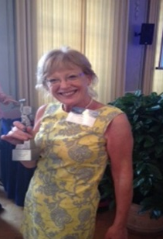
Ann Heelan honoured with the Myriam Van Acker Award
Ann Heelan, Executive Director of AHEAD was awarded the Myriam Van Acker Award at the Eighth International Conference on Higher Education and Disability in Innsbruck, Austria, 2013. This award is only given out every three years to a professional who through leadership and innovation has made a big impact in the world of disability and higher education and has never been received by an Irish person before.

Report highlights the ‘brain drain’
A recent study in Ireland has revealed that the country is experiencing a “brain drain” with large numbers of educated young people emigrating to find work abroad. The report by the University of Cork College Émigré project found that emigrants leaving Ireland had an overall higher level of education than the overall Irish population. The research found that 62% of emigrants aged 25 – 34 have a university qualification – compared to 49% of Irish people in that age range overall.
// Autonomy & Inclusion Read More

Mental Well Being – Are you ready to start your conversation?
- The 80-plus organisations behind the See Change partnership have launched a new video tackling those old mental health clichés that are really quite unhelpful when supporting someone who is going through a tough time or encouraging more openness around mental health. Stigma breeds silence around mental health that stops people seeking help and makes the experience of being unwell much harder. Is it any wonder that See Change research found that 1 in 2 Irish people would rather suffer in silence? Are you ready to start your conversation?
WATCH VIDEO: http://www.youtube.com/watch?v=IUUwEv8q4LI&feature=youtu.be
- Mental and emotional distress has increased during recession, experts say (IT 10/10/13) Check out 21,000 people urge Government to invest promised funds in mental health services
- Read up ‘Mind Yourself’ a week-long Irish Independent series
- Tune in to Time to Talk a week-long series from TV3 Ireland AM
- Engage with Positive Mental Health Live Blog - Newstalk FM

Best of luck to Gerard Gallagher
Gerard Gallagher came to AHEAD on an internship where he worked in a variety of areas but with a mandate to harness the voice of students with disabilities. As a recent graduate of the Boston College, Irish Institute, Disabilities and Access study programme, Gerard has recently left AHEAD to take up the role of disability advisor with NUI, Maynooth responsible for the provision of supports for students with physical disabilities, neurological conditions and significant ongoing illnesses. We wish him every success. He is also involved in ‘UrAbility’ a company that provides AT support to students with specific learning difficulties www.urability.com.

Contact:
AHEAD, East Hall, UCD, Carysfort Avenue, Blackrock, Co. Dublin

Tel: 01 7164396 | E-mail: ahead@ahead.ie
w: www.ahead.ie | facebook.com/ahead.ie | @aheadireland

